

I.E. Weldon Secondary School

**Geography of Canada - Grade 9 (CGC1PR)**

Teacher: Mrs. Hendren Room: 218

Voicemail: 324-3585 Extension: 19030

Email: j.hendren@tldsb.on.ca

Website: hendren.weebly.com 🡪 **Grade 9 Geo**

**Geography of Canada:** One of the most rewarding things for students is to study about their own country. This enables them to discover more about themselves and their environment as well as the world that awaits them beyond school. In the case of Canada, we have an extraordinarily diverse country. We have people with the national backgrounds of almost every country in the world. In addition, we have natural, physical landscapes that vary across the country. It is the interaction of these human and physical elements that makes the geography of the country so fascinating to observers. Over the course of the semester we will be examining Canada’s geography so that we might learn more about this country’s physical and social systems and Canada’s role in the world.

 **Units of Study**:

* Canada on a World Stage
* Interactions in the Physical Environment
* Managing Canada’s Resources and Industries
* Changing Populations

**Mark Distribution**

**Term Evaluation Criteria**:

* Assignments 30%

70%

* Tests and quizzes 40%

**Culminating Activities**:

* Culminating Assignment 20%

30%

* Final Examination 10%

**100%**

**Total**

**In an effort to improve student task completion and to reward consistent daily contributions, students who earn a term average of 70% or greater in any grade 9 course, with all assignments completed and submitted according to the teacher’s deadlines, will be exempt from their exam. Students and parents may waive the exemption if they so choose. Our goal is to motivate students to complete all of their work, which in turn should improve their overall results.

**Student achievement will be reported in all courses at the following times:**

Student achievement will be reported in all courses at the following times:

Mark Update Week – October 16 – 20, 2017

Parent’s Night – October 26, 2017 – 4:30-7:00pm Interim Report Card – November 17, 2017

Pre-exam Mark Update Week – December 18-22,

2017

Final Report Card – February 9, 2018

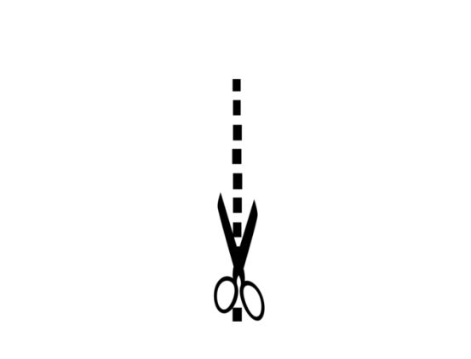

CGC1PR – Geography of Canada

**Parents:** Please read and sign the back of this form then detach this section and send it back to the school. You may wish to keep the rest of this information sheet for future reference as it contains contact information and important dates.

Deadlines

**Assignments:** Students are required to meet ALL deadlines. If you are unable to meet a deadline or you have a planned absence, see me **BEFORE** the due date to negotiate a suitable alternative. ***My goal is to help you be successful, so please see me should the need arise!***

Missed Evaluations

If a student knows in advance they are going to be absent for a test, it is the ***students’*** responsibility to see Mrs. Hendren **BEFORE** the absence to arrange to write the test at an alternate date. In case of illness, the student must provide a note explaining the absence before the test results will be entered. Missed tests will be written the day the student returns to class.

Academic Dishonesty

* Cheating (which includes talking or communicating with other students in ANY way) during tests or exams is forbidden. Academic dishonesty of any kind results in a mark of zero.
* Copied work is considered **PLAGIARISM** or CHEATING and is assigned a mark of zero. Any ideas or words that come from any source other than from personal experience must be formally referenced. Failure to do so is considered plagiarism.

Attendance

* Good attendance is ***essential*** for academic success. Students who have chronic problems with attendance undermine their ability to gain a credit.
* When you return from an absence come to class **EARLY** so you can go directly to the TCOB binder to collect worksheets and assignments you missed. Ask to see another student’s notebook so you can copy down the agenda and notes you missed during your absence. Check the website or come and see me personally at lunch.

CLASSROOM EXPECTATIONS:

* Be on time***!*** *This means you are* ***in your seat WHEN THE FINAL BELL RINGS!***
* **RESPECT** *yourself, all individuals in the room, and the classroom property. No insults or mean comments about yourself or others will be tolerated. Respect other peoples’ right to speak and voice opinions. Be nice to each other!* ☺
* **DO NOT** *use personal entertainment devices (iPod, cell phone etc.), bring food, drinks (water in a sealed bottle is acceptable), to class. Please remove and put away any headphones* ***before*** *entering the classroom and turn off your cell if you carry one.* ***Electronic devices that are inappropriately utilized WILL BE HELD IN THE “CELL PHONE HOTEL” FOR THE PERIOD!!***

Extra Help Policy:

*Understanding concepts and mastery of skills is essential to your success but is certainly not always easy. We want to see you succeed. I am available to provide extra help before and after school as well as at lunch. PLEASE come and see me as soon as you encounter any difficulties so we can set up a time that is mutually convenient.* ***Please take responsibility for YOUR OWN learning and seek the help you need.*** *If you show evidence of effort and an interest in success, I will certainly do all I can to assist you in attaining your goals!*

CONTACT INFORMATION!

***If you have any questions, concerns or comments at any point throughout the semester please do not hesitate to contact me at:***

***324-3585 ext. 19030 or email me at j.hendren@tldsb.on.ca***

I maintain a website that will give you access to course material and important dates:

hendren.weebly.com OR it can be accessed through Weldon’s website under “Staff List”



Please sign below in the space provided to acknowledge you have read and understood this course information document and return this portion to Mrs. Hendren.



Student Name (Please Print) Student Signature

Parent/Guardian Signature ______________________________________________________

**Parent/Guardian email if you would like to utilize email as a form of communication: __________________________________________**